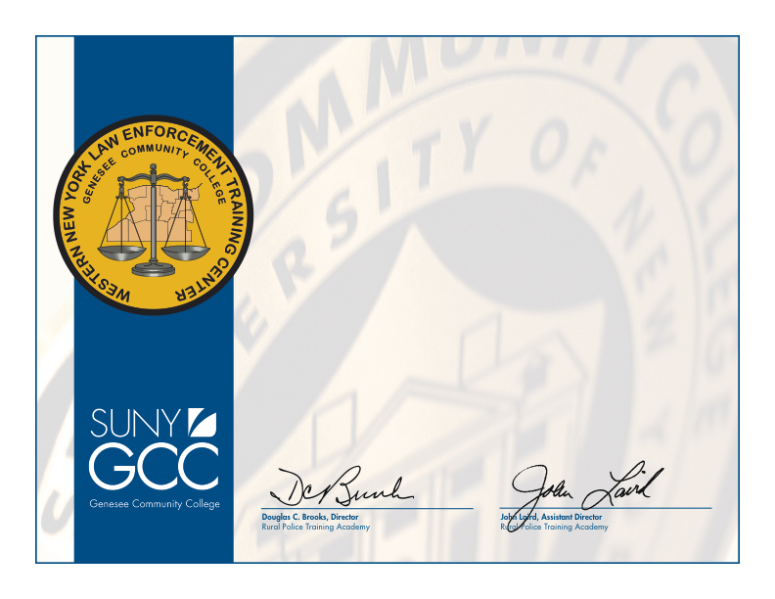

Genesee Community College

Rural Police Training Academy

Certificate of Achievement

hereby presented to

Joshua D. Smith

for your dedicated service as

PLATOON LEADER

2012–2013 basic course for police

presented this 1st day of March 2013